Gig Services Recommendation Method for Fuzzy Requirement Description (TBD)
Subtitle as needed

Authors Name/s per 1st Affiliation (Author)
line 1 (of Affiliation): dept. name of organization
line 2: name of organization, acronyms acceptable
line 3: City, Country
line 4: e-mail: name@xyz.com
Authors Name/s per 2nd Affiliation (Author)
line 1 (of Affiliation): dept. name of organization
line 2: name of organization, acronyms acceptable
line 3: City, Country
line 4: e-mail: name@xyz.com

Abstract—This electronic document is a “live” template. The various components of your paper [title, text, heads, etc.] are already defined on the style sheet, as illustrated by the portions given in this document. DO NOT USE SPECIAL CHARACTERS, SYMBOLS, OR MATH IN YOUR TITLE OR ABSTRACT. (Abstract)
Keywords-component; formatting; style; styling; insert (key words)

Introduction (Heading 1)
All manuscripts must be in English. These guidelines include complete descriptions of the fonts, spacing, and related information for producing your proceedings manuscripts. Please follow them and if you have any questions, direct them to the production editor in charge of your proceedings at Conference Publishing Services (CPS): Phone +1 (714) 821-8380 or Fax +1 (714) 761-1784.
This template provides authors with most of the formatting specifications needed for preparing electronic versions of their papers. All standard paper components have been specified for three reasons: (1) ease of use when formatting individual papers, (2) automatic compliance to electronic requirements that facilitate the concurrent or later production of electronic products, and (3) conformity of style throughout a conference proceedings. Margins, column widths, line spacing, and type styles are built-in; examples of the type styles are provided throughout this document and are identified in italic type, within parentheses, following the example. PLEASE DO NOT RE-ADJUST THESE MARGINS. Some components, such as multi-leveled equations, graphics, and tables are not prescribed, although the various table text styles are provided. The formatter will need to create these components, incorporating the applicable criteria that follow.

Overview

Preliminary & Problem Definition
As we have mentioned before, our service recommendation algorithms mainly conduct on knowledge graph. So we first start with some preliminaries and show how we established a whole graph from the raw data crawled early.
- 目标图与查询图：
Target Graph. A target graph that represents all the entities, attributes and relationships of the fiverr can be defined as a labeled, directed graph G = (V, E, L), with the node set V, edge set E, and a label function L, where (1) each node u∈V represents an entity in the network, (2) each edge e∈E denotes the relationship between two entities, and (3) L is a function that assigns to each node u (or edge e) a label L(u) (or L(e)) from a finite alphabet. In our fiverr dataset (1) the node labels can represent the type or attributes of the entities, e.g., name, tags, etc. (2) the edge labels represent the relation type between its corresponding two entities, e.g., isA, releaseBy, etc.
Query Graph. A query graph Q = (V_{Q}, E_{Q}, L_{Q}) is a directed labeled graph, with a set of query nodes V_{Q}, a set of query edges E_{Q}, and a label function L_{Q}, which assigns to each query node v∈V_{Q} a label L_{Q}(v) from a finite alphabet. Normally a query graph is not big and aims to describe a certain service corresponding to consumer’s requirements.
- LSH
由于在进行子图匹配的过程中需要计算出待匹配节点的相似度，而作为服务的主要描述信息，服务的主题将是匹配过程中非常关心的一个属性。要想刻画出用户需求输入与我们所构建知识图谱中的单个服务主题的相似度需要用到自然语言处理方面的知识，本文选取LSH作为计算主题相似度的算法。局部敏感哈希(Locality Sensitive Hashing，LSH)算法是一种衡量文本相似度的算法。局部敏感哈希是近似最近邻搜索算法中最流行的一种，它有坚实的理论依据并且在高维数据空间中表现优异。它的主要作用就是从海量的数据中挖掘出相似的数据，可以具体应用到文本相似度检测、网页搜索等领域。局部敏感哈希是相对的，并不能做到绝对，LSH能做到的就是保持最大可能的相似度。

Framework

GSR4FR method (方法的具体描述)

数据采集
The goal of our experiments is to propose such Top-K recommended services based on the user input which described their real requirements and some restrictions on external conditions. In the following sections the experiments will be conducted on the dataset crawled from fiverr. fiverr is a service provider website which allows registered sellers to release various services based on their different skills while simultaneously consumers can buy the corresponding services to satisfy their demands. To get the initial data we just simply download every pages of the website then extract required information and stored in relational database.

构图
Considered our knowledge graph we have particular node types, edge types and different attributes which showed blow:
node types | category | seller | consumer | gig | comment
edge types | isA | releaseBy | belongTo
attributes | name | title | price | score | timespan | nationality | language | etc.
Table 1: Notations: Node Types, Edge Types and Attributes
为了存储整个知识图谱我们选择Neo4j作为数据库， Neo4j是一个高性能的NOSQL图形数据库，它将结构化数据存储在网络上而不是表中。Neo4j也可以被看作是一个高性能的图引擎，该引擎具有成熟数据库的所有特性。同时Neo4j具有很好的数据可视化支持，下图是经过Neo4j可视化后的网站知识图谱。
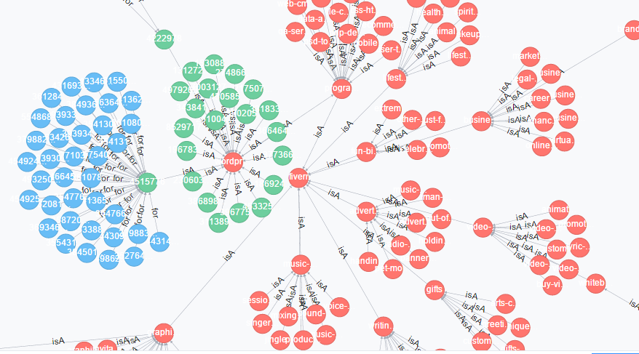
Figure 1: Target Graph
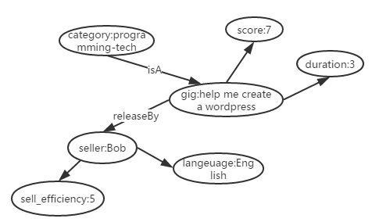
Figure 2: Query Graph
Figure 1&2 shows a part of target graph and a typical example of query graph. To build the whole target graph, we used Neo4j to store all the entities, edges and attributes also it can assist us to conveniently visualize the knowledge graph. As a query graph it’s structure can be either complicated or simple, there is no necessity to contain all the information in one graph whereas the requirements of consumer usually focus one or two certain area.

需求→查询子图
In order to precisely get consumers’ demands we adopt a Guided Requirement Completion method to automatically guess consumers’ potential requirements and give them instructions to complete it.
Firstly, we get a sentence from the consumer’s input which generally describes his/her desired service. After analysis of the existing data in the knowledge graph we find that every service entity has an attribute named title which can be roughly considered as the description of the service. So we employ LSH(Locality-Sensitive Hashing) method to cursorily calculate the semantic similarity between consumer’s input and each title of services in the target graph. Now the consumers’ ideal services can be extracted from the outputs of LSH, considered the output value indicates the similarity of corresponding titles the Top-N LSH scored services will be chosen as consumers’ possible selection.
Secondly, based on the possible selections all the attributes will be classified and for each attribute we can counted all the entities to generate a range of its value. By simply divide the attribute’s possible value into different scopes a relatively complete requirement will be generated based on the user’s options.
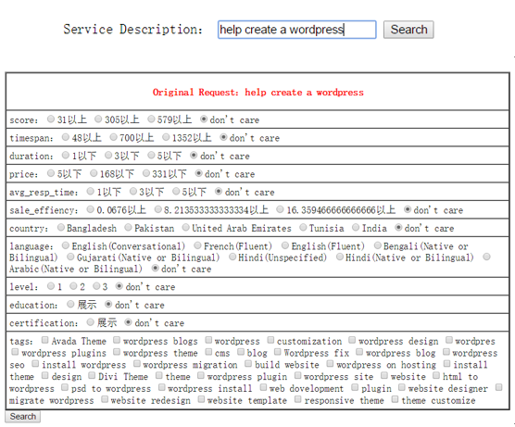
Figure 2: Requirement complete interface

查询子图→Top-N
Based on the complete requirement a query graph will be created. Then our key problem is how to get a proper subgraph of the query graph in the target graph. There are many algorithms to apply subgraph matching techniques such as BLINKS, SAGA, NESS, NeMa, etc. In this paper we choose NEMA as our fast subgraph matching algorithms, for (1) it proposes a novel subgraph matching cost metric that aggregates the costs of matching individual nodes, and unifies both structure and node label similarities. (2) based on the metric, NeMa formulate the minimum cost subgraph matching problem and propose a heuristic algorithm for solving the problem based on an inference model. (3) NeMa is both effective and efficient compared to the keyword search and various state-of-the-art graph querying techniques through lots of experiments.

Algorithm NeMa
Input: Target graph G(V, E, L), Query Graph Q(V_{Q}, E_{Q}, L_{Q}).
Output:Top-N Minimum cost matching of Q in G.
1. for each node v ∈ V_{Q} do compute M(v);
2. i := 0; flag := true;
3. Initiate iterative inferencing;
4. while flag do
5. i := i + 1;
6. for each v ∈ V_{Q} do
7. for each u ∈ M(v) do
8. compute Ui(v, u);
9. keep track of the current matches of neighbors v0 ∈ N(v);
10. compute optimal match Oi(v)
11. if more than a threshold number of query nodes v satisfy Oi(v) = Oi−1(v) then
12. flag := false;
13. construct Φ for all v ∈ V_{Q}
14. return Φ;
Figure 4: Iterative Inference Algorithm NeMa
Figure 4 shows the algorithm to generate Top-N matching results from target graph, by properly adjust the threshold we can control the number of N.

Experiments
Before you begin to format your paper, first write and save the content as a separate text file. Keep your text and graphic files separate until after the text has been formatted and styled. Do not use hard tabs, and limit use of hard returns to only one return at the end of a paragraph. Do not add any kind of pagination anywhere in the paper. Do not number text heads-the template will do that for you.
Finally, complete content and organizational editing before formatting. Please take note of the following items when proofreading spelling and grammar:

Dataset Description

Experiment Result of GSR4FR method (每个步骤的实验结果)
论文将现有的fiverr数据集划分为不同的数量级分别应用本文提出的方法进行实验，其中最大的数量级为5000条服务，最小的为1000条服务。实验的测试集为500条，分别以论文中提出的引导式搜索方法和直接在大图中进行搜索的方法进行对比，下图是两种方法在不同数量级下平均运行时间的增长趋势以及对比。
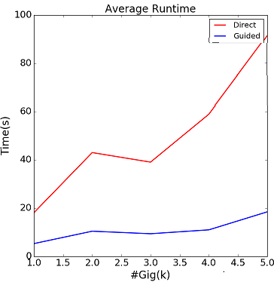
Figure 5: Average Runtime of Different Methods
从图中我们可以看出采用直接搜索的方式平均耗时过大且增长幅度也远高于引导式的搜索方法，因此我们所提出的方法在实际应用中是具有一定可行性的。
接下来实验就两种方法最终返回的平均Top-N数量进行了对比，并且还考量了引导式搜索方法在整个搜索空间中每次压缩比例的具体情况。
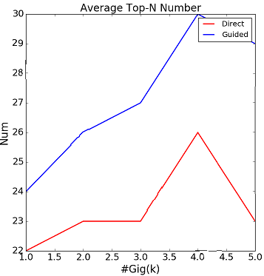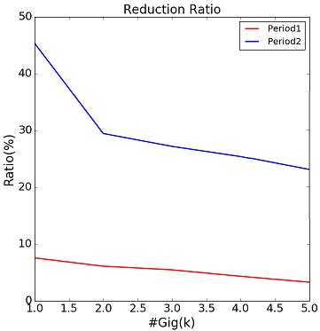
Figure 6: #Top-N & Reduction ratio of Different Methods
实验结果显示，采用引导式搜索方法返回的Top-N数量会随着实验数据集的增长而增加，而直接搜索返回的最终Top-N数量并没有随着数据集的增加产生明显的变化。同时，采用引导式的搜索方法在产生最终结果之前经过了两轮数据压缩，起到了很好的缓冲作用，也提高整个搜索过程的效率。
最后，我们还对比了以上两种方法在每个数量级下返回服务的最优占比情况，实验中主要统计了Top-3、Top-5、以及Top-10所包含的最优服务的平均值，具体数据在下表中展示:
表2：两种方法最优服务占比情况
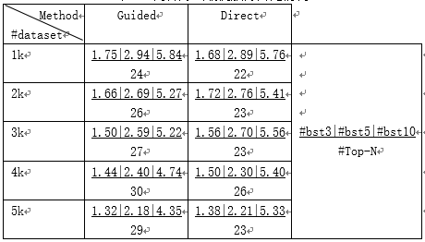
通过对实验结果的分析可以看出，论文提出的引导式搜索方法最终得到的最优服务占比与传统的直接搜索方法相比没有太大的差别，但是在搜索时间上得到了很大地提升。因此在提升效率的同时保证了算法的可信度。(#bst3:排名前3的服务中最优服务平均数量；#bst5:排名前5的服务中最优服务平均数量；#bst0:排名前10的服务中最优服务平均数量；#Top-N:方法返回的所有服务平均数量)

Case Study(如果有的话)

Related Work
After the text edit has been completed, the paper is ready for the template. Duplicate the template file by using the Save As command, and use the naming convention prescribed by your conference for the name of your paper. In this newly created file, highlight all of the contents and import your prepared text file. You are now ready to style your paper.

Authors and Affiliations
The template is designed so that author affiliations are not repeated each time for multiple authors of the same affiliation. Please keep your affiliations as succinct as possible (for example, do not differentiate among departments of the same organization). This template was designed for two affiliations.

For author/s of only one affiliation (Heading 3): To change the default, adjust the template as follows.

Selection (Heading 4): Highlight all author and affiliation lines.

Change number of columns: Select Format >
Columns >Presets > One Column.

Deletion: Delete the author and affiliation lines for the second affiliation.

For author/s of more than two affiliations: To change the default, adjust the template as follows.

Selection: Highlight all author and affiliation lines.

Change number of columns: Select Format >
Columns > Presets > One Column.

Highlight author and affiliation lines of affiliation 1 and copy this selection.

Formatting: Insert one hard return immediately after the last character of the last affiliation line. Then paste the copy of affiliation 1. Repeat as necessary for each additional affiliation.

Reassign number of columns: Place your cursor to the right of the last character of the last affiliation line of an even numbered affiliation (e.g., if there are five affiliations, place your cursor at end of fourth affiliation). Drag the cursor up to highlight all of the above author and affiliation lines. Go to Format > Columns and select “2 Columns”. If you have an odd number of affiliations, the final affiliation will be centered on the page; all previous will be in two columns.

Identify the Headings
Headings, or heads, are organizational devices that guide the reader through your paper. There are two types: component heads and text heads.
Component heads identify the different components of your paper and are not topically subordinate to each other. Examples include Acknowledgments and References and, for these, the correct style to use is “Heading 5”. Use “figure caption” for your Figure captions, and “table head” for your table title. Run-in heads, such as “Abstract”, will require you to apply a style (in this case, italic) in addition to the style provided by the drop down menu to differentiate the head from the text.
Text heads organize the topics on a relational, hierarchical basis. For example, the paper title is the primary text head because all subsequent material relates and elaborates on this one topic. If there are two or more sub-topics, the next level head (uppercase Roman numerals) should be used and, conversely, if there are not at least two sub-topics, then no subheads should be introduced. Styles named “Heading 1”, “Heading 2”, “Heading 3”, and “Heading 4” are prescribed.

Figures and Tables

Positioning Figures and Tables: Place figures and tables at the top and bottom of columns. Avoid placing them in the middle of columns. Large figures and tables may span across both columns. Figure captions should be below the figures; table heads should appear above the tables. Insert figures and tables after they are cited in the text. Use the abbreviation “Fig. 1”, even at the beginning of a sentence.
- Table Type Styles
Table Head | Table Column Head
Table Head | Table column subhead | Subhead | Subhead
copy | More table copyª
a. Sample of a Table footnote. (Table footnote)
We suggest that you use a text box to insert a graphic (ideally 300 dpi), with all fonts embedded) because, in an MSW document, this method is somewhat more stable than directly inserting a picture.
To have non-visible rules on your frame, use the MSWord pull-down menu, select Format > Borders and Shading > Select “None”.
- Example of a ONE-COLUMN figure caption.
Please see last page of this document for AN EXAMPLE of a 2-COLUMN Figure.
Figure Labels: Use 8 point Times New Roman for Figure labels. Use words rather than symbols or abbreviations when writing Figure axis labels to avoid confusing the reader. As an example, write the quantity “Magnetization”, or “Magnetization, M”, not just “M”. If including units in the label, present them within parentheses. Do not label axes only with units. In the example, write “Magnetization (A/m)” or “Magnetization {A[m(1)]}”, not just “A/m”. Do not label axes with a ratio of quantities and units. For example, write “Temperature (K)”, not “Temperature/K”.

Footnotes
Use footnotes sparingly (or not at all) and place them at the bottom of the column on the page on which they are referenced. Use Times 8-point type, single-spaced. To help your readers, avoid using footnotes altogether and include necessary peripheral observations in the text (within parentheses, if you prefer, as in this sentence).

Conclusion
You must submit the IEEE Electronic Copyright Form (ECF) per Step 7 of the CPS author kit’s web page. THIS FORM MUST BE SUBMITTED IN ORDER TO PUBLISH YOUR PAPER.
Please see Step 9 for ordering reprints of your paper. Reprints may be ordered using the form provided as <reprint.doc> or <reprint.pdf>.

Acknowledgment
The preferred spelling of the word “acknowledgment” in America is without an “e” after the “g”. Avoid the stilted expression, “One of us (R.B.G.) thanks . . .” Instead, try
“R.B.G. thanks”. Put applicable sponsor acknowledgments here; DO NOT place them on the first page of your paper or as a footnote.

References
List and number all bibliographical references in 9-point Times, single-spaced, at the end of your paper. When referenced in the text, enclose the citation number in square brackets, for example [1]. Where appropriate, include the name(s) of editors of referenced books. The template will number citations consecutively within brackets [1]. The sentence punctuation follows the bracket [2]. Refer simply to the reference number, as in [3]—do not use “Ref. [3]” or “reference [3]” except at the beginning of a sentence: “Reference [3] was the first . . .”
Number footnotes separately in superscripts. Place the actual footnote at the bottom of the column in which it was cited. Do not put footnotes in the reference list. Use letters for table footnotes.
Unless there are six authors or more give all authors’ names; do not use “et al.”. Papers that have not been published, even if they have been submitted for publication, should be cited as “unpublished” [4]. Papers that have been accepted for publication should be cited as “in press” [5]. Capitalize only the first word in a paper title, except for proper nouns and element symbols.
For papers published in translation journals, please give the English citation first, followed by the original foreign-language citation [6].

- G. Eason, B. Noble, and I. N. Sneddon, “On certain integrals of Lipschitz-Hankel type involving products of Bessel functions,” Phil. Trans. Roy. Soc. London, vol. A247, pp. 529–551, April 1955. (references)
- J. Clerk Maxwell, A Treatise on Electricity and Magnetism, 3rd ed., vol. 2. Oxford: Clarendon, 1892, pp.68–73.
- I. S. Jacobs and C. P. Bean, “Fine particles, thin films and exchange anisotropy,” in Magnetism, vol. III, G. T. Rado and H. Suhl, Eds. New York: Academic, 1963, pp. 271–350.
- K. Elissa, “Title of paper if known,” unpublished.
- R. Nicole, “Title of paper with only first word capitalized,” J. Name Stand. Abbrev., in press.
- Y. Yorozu, M. Hirano, K. Oka, and Y. Tagawa, “Electron spectroscopy studies on magneto-optical media and plastic substrate interface,” IEEE Transl. J. Magn. Japan, vol. 2, pp. 740–741, August 1987 [Digests 9th Annual Conf. Magnetics Japan, p. 301, 1982].
- M. Young, The Technical Writer’s Handbook. Mill Valley, CA: University Science, 1989.
- Electronic Publication: Digital Object Identifiers (DOIs):
Article in a journal:
- D. Kornack and P. Rakic, “Cell Proliferation without Neurogenesis in Adult Primate Neocortex,” Science, vol. 294, Dec. 2001, pp. 2127-2130, doi:10.1126/science.1065467.
Article in a conference proceedings:
- H. Goto, Y. Hasegawa, and M. Tanaka, “Efficient Scheduling Focusing on the Duality of MPL Representatives,” Proc. IEEE Symp. Computational Intelligence in Scheduling (SCIS 07), IEEE Press, Dec. 2007, pp. 57-64, doi:10.1109/SCIS.2007.357670.

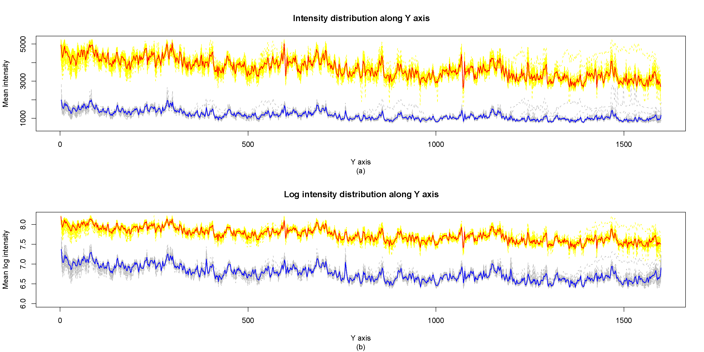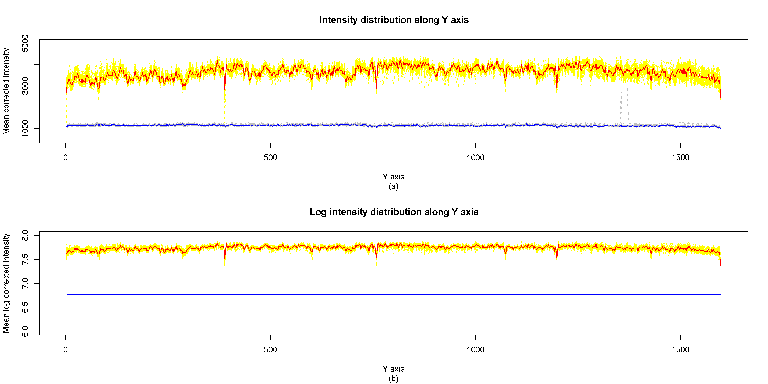
- Example of a TWO-COLUMN figure caption: (a) this is the format for referencing parts of a figure.

